Chapter 16, Problem 27.

Find v(t) for t > 0 in the circuit in Fig. 16.50.
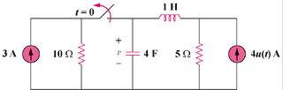

Figure 16.50
For Problem 16.27.

